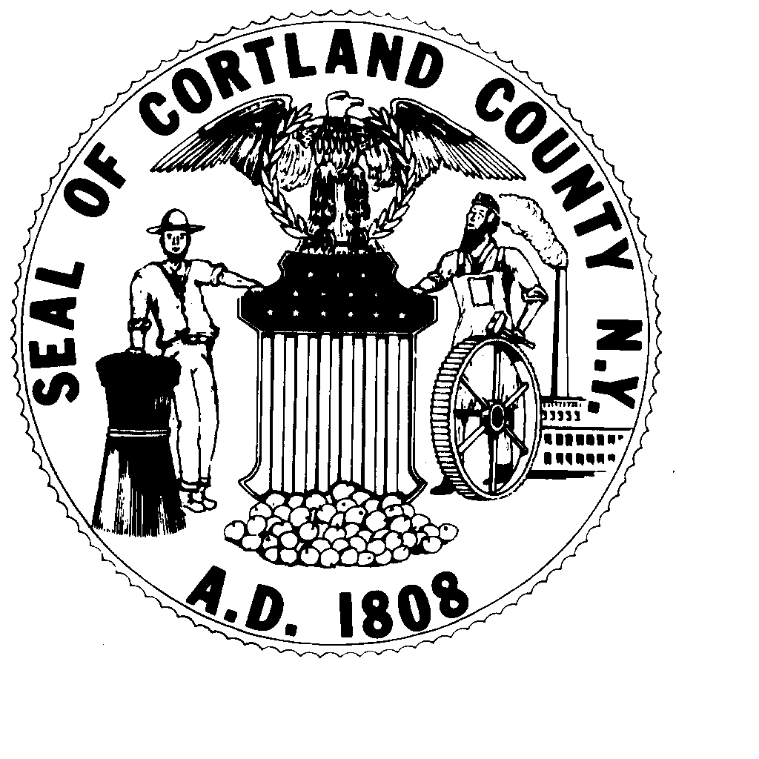
Cortland County Board of Elections
112 River Street, Suite 1
Cortland, NY 13045-2828
Tel: 607-753-5032 Fax: 607-758-5513

Robert C. Howe, Commissioner Thomas H. Brown, Commissioner

OFFICES UP FOR ELECTION 2013

COUNTY OFFICES
Surrogate & Family Court Judge 10 Year Term
Legislators (17) 2 Year Term

CITY OF CORTLAND

City Judge 10 Year Term

Mayor 2 Year Term
Alderperson (8) 2 Year Term
Constable (2) 2 Year Term

TOWNS
HOMER:
Justice 4 Year Term
Councilperson (2) 4 Year Term
Sup. Of Highways 4 Year Term

CORTLANDVILLE:
Supervisor 2 Year Term
Clerk/Collector 2 Year Term
Justice 4 Year Term
Councilperson (2) 4 Year Term
Sup. Of Highways 2 Year Term

PREBLE:
Supervisor 2 Year Term
Clerk/Collector 2 Year Term
Councilperson (2) 4 Year Term
Sup. Of Highways 2 Year Term

SCOTT:
Supervisor 2 Year Term
Clerk/Collector 2 Year Term
Justice 4 Year Term
Councilperson (2) 4 Year Term
Sup. Of Highways 2 Year Term

CUYLER:
Supervisor 2 Year Term
Clerk/Collector 2 Year Term
Councilperson (2) 4 Year Term
Sup. Of Highways 4 Year Term

SOLON:
Supervisor 4 Year Term
Clerk/Collector 4 Year Term
Justice 4 Year Term
Councilperson (2) 4 Year Term
Sup. Of Highways 4 Year Term

TRUXTON:
Supervisor 2 Year Term
Clerk/Collector 4 Year Term
Councilperson (2) 4 Year Term
Sup. Of Highways 4 Year Term

CINCINNATUS:
Supervisor 2 Year Term
Clerk 2 Year Term
Councilperson (2) 4 Year Term
Tax Collector 2 Year Term

FREETOWN:
Supervisor 2 Year Term
Clerk 2 Year Term
Councilperson (2) 4 Year Term
Sup. Of Highways 2 Year Term
Tax Collector 2 Year Term

TAYLOR:
Clerk/Collector 2 Year Term
Councilperson (2) 4 Year Term
Sup. Of Highways 4 Year Term

WILLET:
Supervisor 2 Year Term
Clerk 4 Year Term
Councilperson (2) 4 Year Term
Sup. Of Highways 4 Year Term
Tax Collector 2 Year Term

LAPEER:
Councilperson (2) 4 Year Term

MARATHON:
Supervisor 2 Year Term
Clerk 2 Year Term
Councilperson (2) 4 Year Term
Sup. Of Highways 2 Year Term
Tax Collector 2 Year Term

HARFORD:
Supervisor 2 Year Term
Clerk/Collector 2 Year Term
Councilperson (2) 4 Year Term

VIRGIL:
Supervisor 2 Year Term
Clerk/Collector 2 Year Term
Councilperson (2) 4 Year Term
Sup. Of Highways 4 Year Term

